


Get IN.FORMed
IN.FORM is a unique weight-management and healthy lifestyle program from Nature’s Sunshine, the world leader in premium-quality health supplements.
It’s a 13-week journey to:
- improved energy and vitality
- happiness and greater self-image
- better health habits
- emotional balance
- and yes, weight loss

THE MOST COMPREHENSIVE WEIGHT LOSS APPROACH

The IN.FORM program includes ALL of the following:
- Weekly accountability sessions.
- Discover your body’s unique strengths and needs! Track your health markers weekly using our unique IN.FORM BioTracker that measures weight, body fat percentage, hydration levels, lean muscle mass, metabolic age, bone mass and more!
- Health Education. Gain knowledge and life skills to achieve lasting health.
- Social Support. A fun group setting gives you an instant social network. Friends with similar goals help you along your journey to success.
- Personalized, Flexible Programs. Eat what you want and we’ll customize a Nature’s Sunshine supplement program to meet your individual needs. No pre-packaged meals!
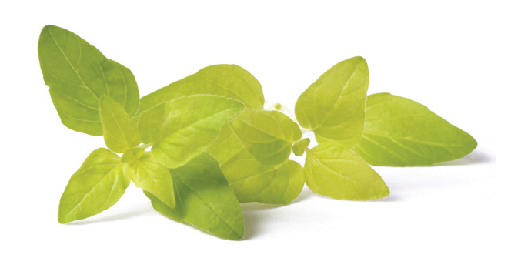
For more information:
Lucy Taylor, C.H.H.P.
Phoenix Holistic Healing Clinic
Phone: 250-758-0660
Email: phoenixhealing@shaw.ca
Website: www.phoenixhealing.ca
NSP # 1520546

GET YOUR HEALTH MARKERS CHECKED:
Metabolic Age
Body Fat %
Body Water %
Muscle Mass
Bone Mass
Visceral Fat (waistline)

